**Over The Wire**

## Level 2 to Level 3

**Step 6: SSH Login**

**Password**: **263JGJPfgU6LtdEvgfWU1XP5yac29mFx**

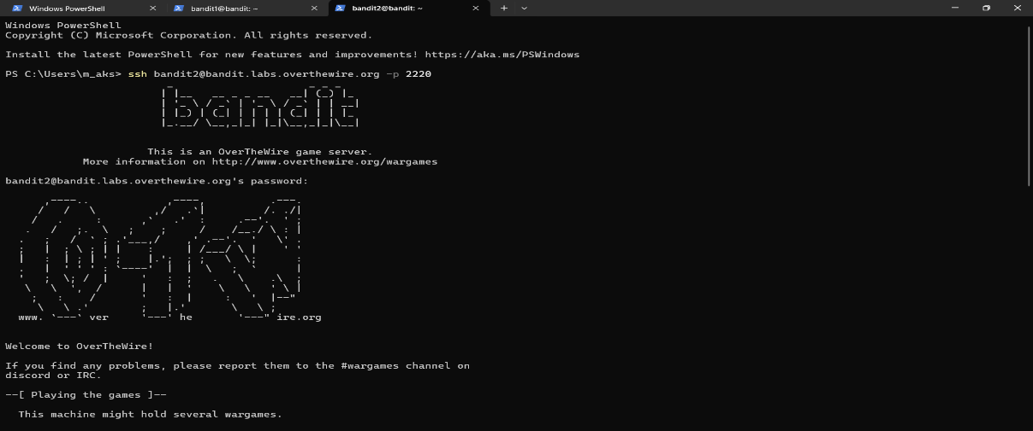

**Step 2: Find Hidden Files (ls -alps)**

**Step 3: Read the file with spaces (cat spaces\ in\ this\ filename)**

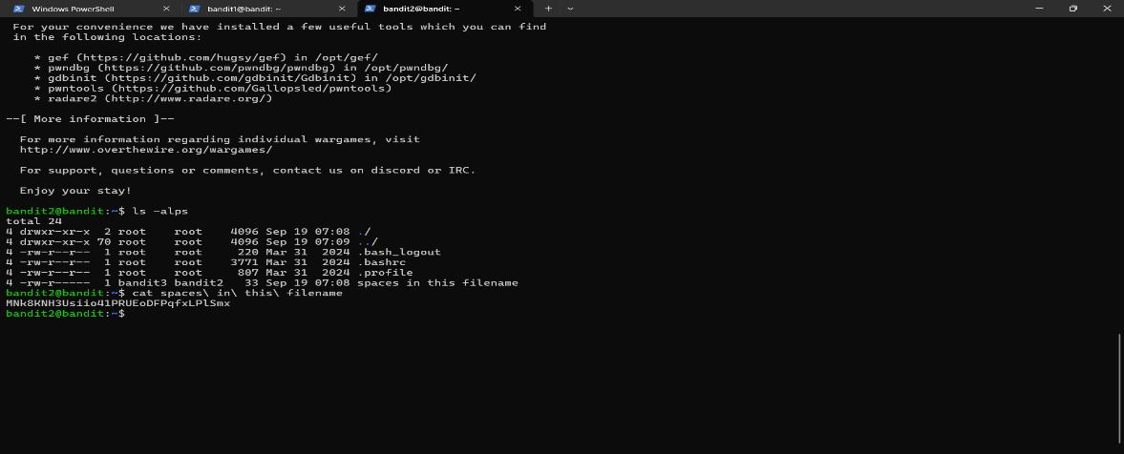

**Output:**

**Password:** **MNk8KNH3Usiio41PRUEoDFPqfxLPlSmx**